230701228

# Exercise 9

Form Validation System – Documentation

# Overview

The Form Validation System is designed to validate user inputs for email addresses and phone numbers. It provides real-time feedback by displaying error messages if the entered data is invalid.

The system enhances user experience by ensuring only correct information is submitted.

# Objective

To validate form inputs (email and phone number) before submission. To display appropriate error messages using JavaScript and Validator.js. To improve form usability and data accuracy.

# Technologies Used

HTML5 — Form structure CSS3 — Styling and layout

JavaScript — Input validation logic

Validator.js — External JavaScript library for robust validation

# Project Structure

index.html — Contains the form elements and loads required scripts and styles.

style.css — Styles the form layout and error messages.

script.js — JavaScript file handling validation logic.

Validator.js — External library included via CDN.

# Features

Email validation: Ensures the email entered follows a standard email format. Phone number validation: Checks if the input is a valid phone number.

Inline error messages: Displays specific error text immediately below invalid fields. Responsive and clean form design.

# How It Works

User inputs email and phone number into the form.

Upon clicking Submit:

JavaScript checks:

If the email is in a valid format.

If the phone number is a valid mobile number.

If validation fails:

Corresponding error messages are shown in red below each field.

If validation succeeds:

Form values are logged to the console (demo purpose).

# Code Snippets

HTML (**index.html**) html

<!DOCTYPE html>

<html lang="en">

<head>

<meta charset="UTF-8">

<title>Form Validation</title>

<link rel="stylesheet" href="style.css">

</head>

<body>

<div class="container">

<form id="myForm">

<label for="email">Email:</label>

<input type="email" id="email" name="email" required>

<span id="emailError" class="error"></span>

<label for="phone">Phone Number:</label>

<input type="text" id="phone" name="phone" required>

<span id="phoneError" class="error"></span>

<button type="submit">Submit</button>

</form>

</div>

<script src="https://cdnjs.cloudflare.com/ajax/libs/validator/13.6.0/validator.min.js"></script>

<script src="script.js"></script>

</body>

</html> CSS (**style.css**) css

body { font-family: Arial, sans-serif; background-color:

#f4f4f4; display: flex; justify-content: center; align- items: center; height: 100vh; margin: 0; }

.container { background-color: white; padding: 20px; border-radius: 5px; box-shadow: 0 0 10px rgba(0, 0, 0, 0.1);

}

form { display: flex; flex-direction: column;

}

label { margin- bottom: 5px;

}

input { margin-bottom:

10px; padding: 10px; border: 1px solid #ccc; border-radius: 3px;

}

button { padding: 10px; background-color: #28a745; color: white; border:

none; border-radius: 3px; cursor: pointer;

}

button:hover { background- color: #218838; }

.error {

color: red; font- size: 0.875em;

}

JavaScript (**script.js**) javascript

document.getElementById('myForm').addEventListener('submit', function (e) { e.preventDefault();

let email = document.getElementById('email').value;

let phone = document.getElementById('phone').value; let emailError = document.getElementById('emailError'); let phoneError = document.getElementById('phoneError');

// Clear previous error messages emailError.textContent = ''; phoneError.textContent = '';

// Validate email if (!validator.isEmail(email)) { emailError.textContent = 'Please enter a valid email address.';

}

// Validate phone number if (!validator.isMobilePhone(phone, 'any')) { phoneError.textContent = 'Please enter a valid phone number.';

}

// If no errors, log values if (validator.isEmail(email) && validator.isMobilePhone(phone, 'any')) { console.log('Email:', email); console.log('Phone:', phone);

}

});

# Screenshots

Valid Input Form — shows fields ready to submit.

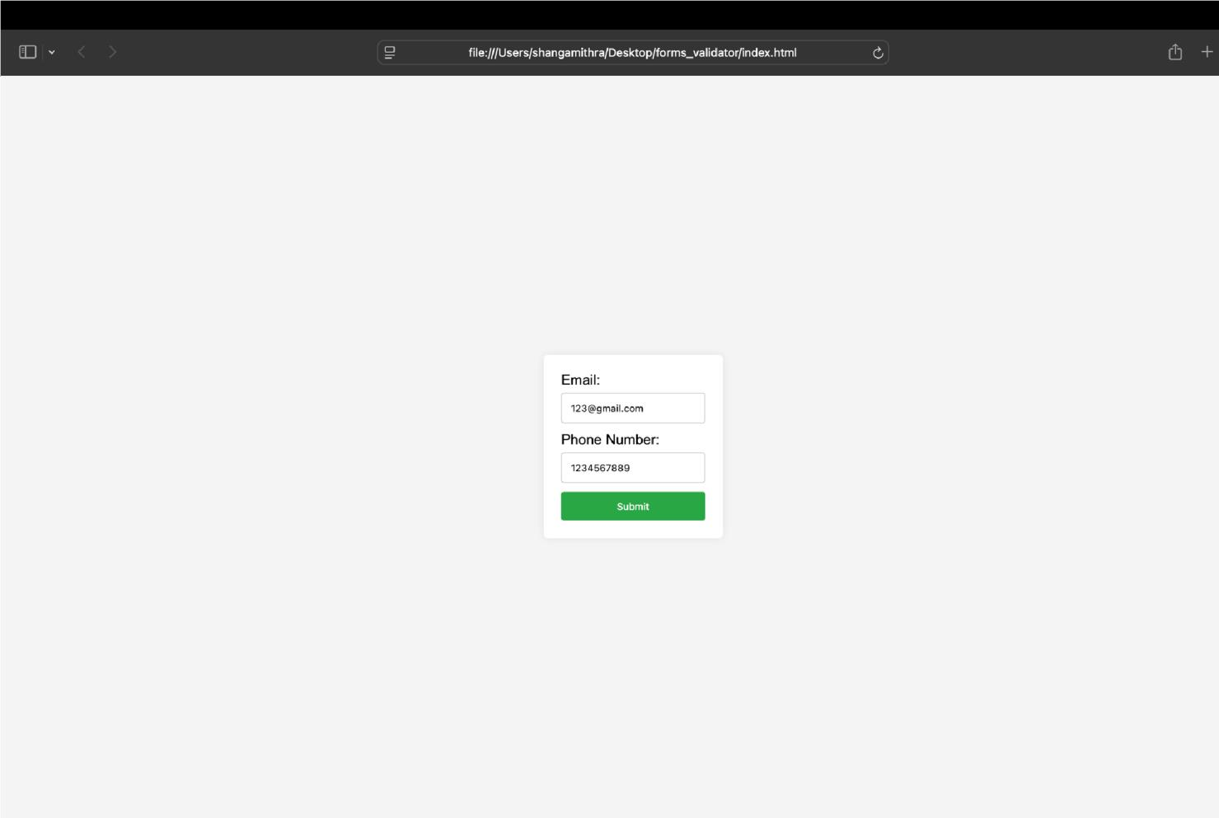

Invalid Input Form — shows error message when incorrect phone number is entered.

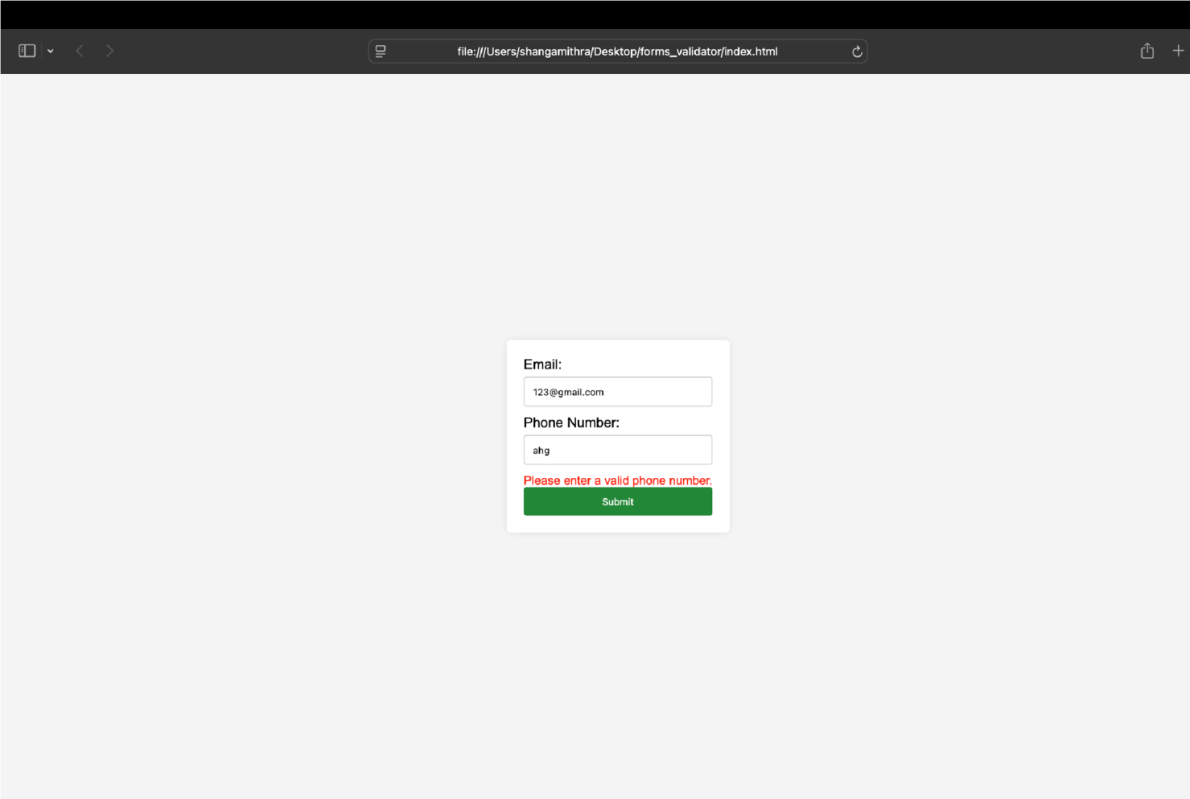

# Conclusion

This project demonstrates real-time form validation using JavaScript and Validator.js, ensuring that data collected from users is accurate and reliable. It offers a strong foundation for building more complex forms in larger web applications.